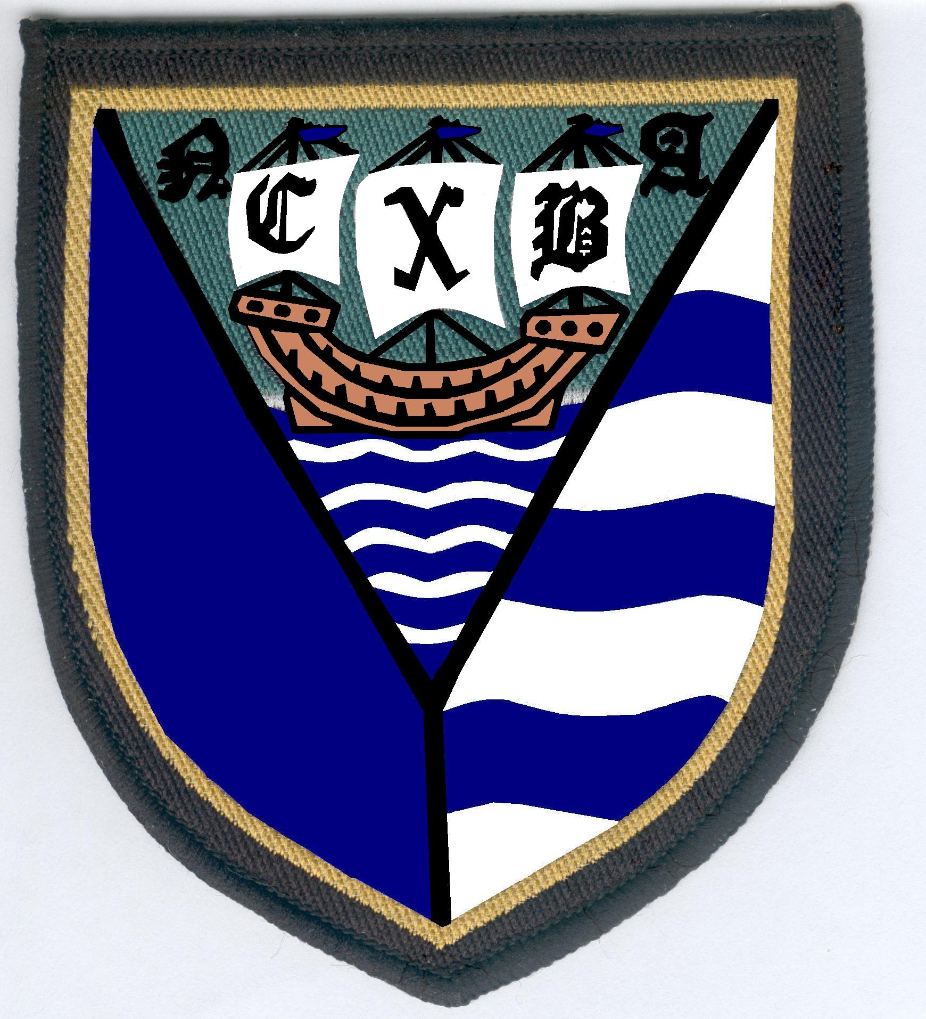
North Cambridgeshire Bowling Association
Website: northcambsebf.co.uk

Bowlers requirements representing North Cambs BA:

Having been selected to play for the Adams, Newton or Derbyshire teams you will be told the date, start time, location of the green and county you are playing. You need to ensure you are there on time so that your bowls are on the green at 1.30pm (Adams and Newton games) for inspection by the umpire.

If selected as a reserve the following requirements must also be followed, you will be given a free meal and selected for the next game.

For Derbyshire games bowls must be on the green for inspection by the umpire at least 15 minutes before the start of the game.

Adams and Newton games are 2 wood triples 31 ends and Derbyshire games 2 wood triples 25 ends.

You are expected to stop for a meal after the game. If you do not want the meal or you want to take a spectator you have until the Tuesday before the game to contact the Captain to cancel your meal or book extra meals.
If meal is not cancelled you will be charged for the meal.

Dress code ref. E.B.F. Yearbook Rule 7.21 for inter county Adams, Newton, Derbyshire and Eversley games.
Each affiliated club is given a new Yearbook at the start of each season.

Players are expected to wear full county dress which is; a navy blazer, white shirt, county tie and grey trousers for formal occasions, arriving at match, match meals and presentations.

County dress for games will be County shirt, navy waterproof County Jacket (both purchased from County at subsidised cost). The Captain will ensure that you have the correct County shirt, navy waterproof County jacket and tie. White trousers (if belt is worn must be white), white underwear, white socks, bowls shoes any colour, if hat worn must be white. If wearing waterproof trousers they must also be white.

Bowls must be be as E.B.F. “laws of the game” section lll page 53, a matching set, with a clearly legible WB/WBB/IBB or BIBC stamp dated 1985 or later.

County stickers will be supplied for attaching to bowls.

Awarding a County badge is made following completion by a player of six (6) matches as part of the Adams, Newton or Derbyshire Team or a mix of these competitions but excluding the Eversley games. Adams and Newton flashes are is awarded following the playing of (6) Adams and (6) Newton games.

All County badges, Adams and Newton Trophy flashes will be awarded by North Cambridgeshire Bowling Association at no cost to the Player.
Any replacements (whether damaged, broken, lost etc.) will be charged to the player.

Dress code for all county finals will be as detailed in the E.B.F. yearbook and will wear a white shirt and club tie or club shirt without a tie. If the club they represent does not have its own tie then player(s) will wear the county tie.

Winners of County Indoor and County Outdoor Finals will be awarded National badges, broaches and swingers if applicable, by the North Cambridgeshire Bowling Association at no cost to the Competitors.
Any replacements (whether damaged, broken, lost etc.) will be charged to the player.

County Indoor and Outdoor winners will be expected to represent North Cambs BA at National E.B.F. finals.
Currently indoor at Newark IBC (April) and outdoor at Skegness (last week of August)

National Finals dress code, in team games all players to wear a county shirt or a white shirt and county tie (no mixture). Mixed games, men will wear a county shirt or white shirt and county tie.

